Case Statement Script.

* case Scripts

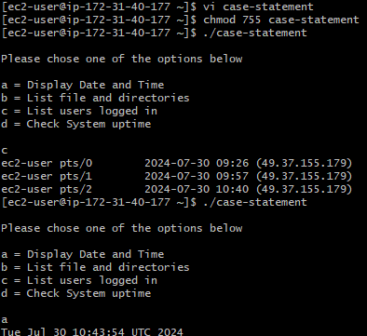

* This script will look at your current day and tell you the state of the  
  backup.

